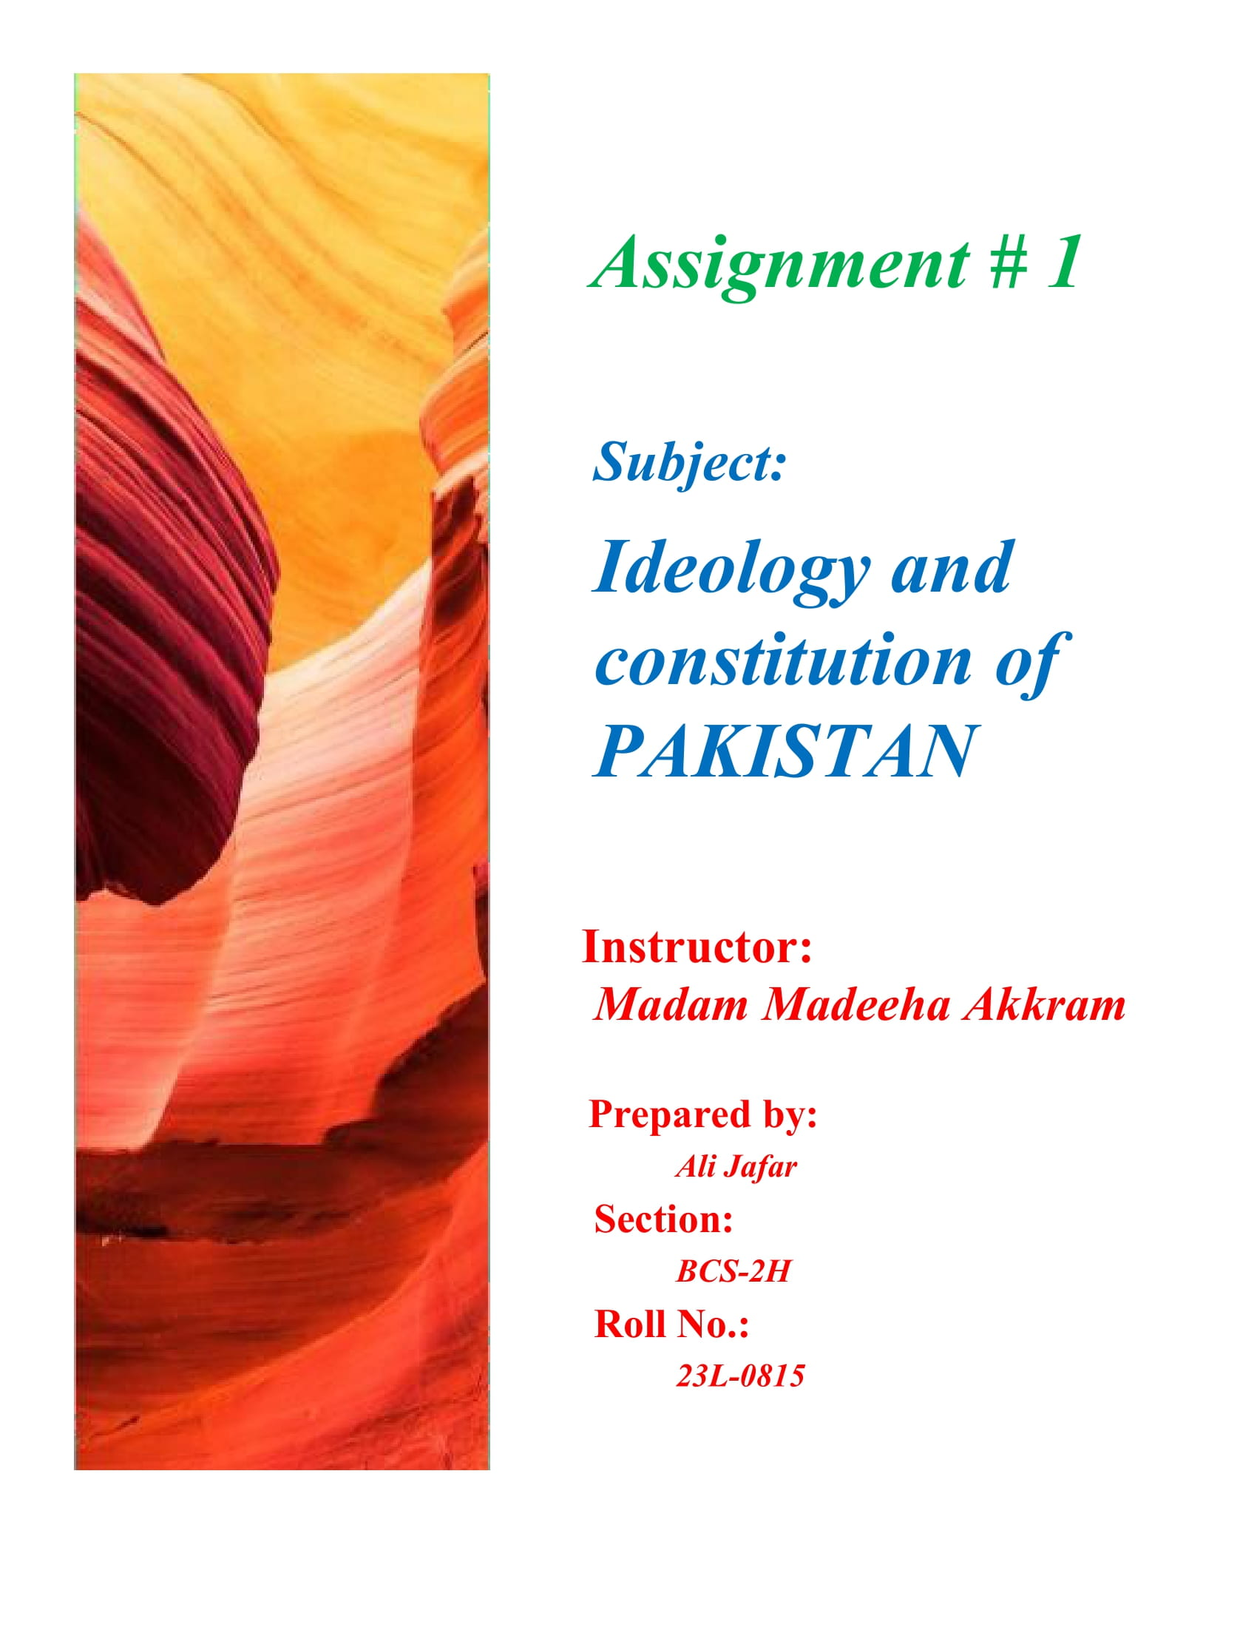

**Corruption and its Impacts on Good**

**Governance in Pakistan**

**Corruption:**

**Corruption** is a form of [dishonesty](https://en.wikipedia.org/wiki/Dishonesty) or a [criminal offense](https://en.wikipedia.org/wiki/Criminal_offense) which is undertaken by a person or an organization which is entrusted in a position of authority, in order to acquire illicit benefits or abuse power for one's personal gain. Corruption may involve many activities which include [bribery](https://en.wikipedia.org/wiki/Bribery), [influence peddling](https://en.wikipedia.org/wiki/Influence_peddling) and [embezzlement](https://en.wikipedia.org/wiki/Embezzlement) and it may also involve practices which are legal in many countries.

**Corruption in Pakistan:**

* **A brief history:**

**“**Corruption is a curse in India and amongst Muslims, especially the so-called

educated and intelligentsia. Unfortunately, it is this class that is selfish and

morally and intellectually corrupt. No doubt this disease is common, but

amongst this particular class of Muslims, it is rampant.**”**

**—( Pakistan founder**[**Jinnah's**](https://en.wikipedia.org/wiki/Muhammad_Ali_Jinnah)**letter to**[**Ispahani**](https://en.wikipedia.org/wiki/Abol_Hassan_Ispahani)**)**

### Since 1947, corruption has been in the roots of Pakistani bureaucracy and it has led to bad governance in Pakistan. In multiple reports published by the [World Bank](https://en.wikipedia.org/wiki/World_Bank), the Pakistani bureaucracy is seen as being rife with corruption, inefficient and bloated in size with an absence of accountability and resistant to change.

### Nationalization politicizes economic planning: 1973–1977

After [Zulfikar Ali Bhutto](https://en.wikipedia.org/wiki/Zulfikar_Ali_Bhutto) came into power in 1973, he introduced a [planned economic system](https://en.wikipedia.org/wiki/Planned_economy) to revitalize the stagnant economy. This led to the Nationalization policy which opened doors for corrupt political practices to seep into the nation's economic planning processes. Accumulated losses of up to [Rs](https://en.wikipedia.org/wiki/Pakistani_rupee) 254 million were reported with several instances of over-staffing and inefficient productivity in heavy mechanical industries.

### Denationalization and political favoritism: 1978–1988

### Bhutto's nationalization program lost its appeal towards the end of his government's term and the demand for denationalization gained more currency. The successive government of [military chief](https://en.wikipedia.org/wiki/Chief_of_Army_Staff_(Pakistan)) and [president](https://en.wikipedia.org/wiki/President_of_Pakistan) [Muhammad Zia-ul-Haq](https://en.wikipedia.org/wiki/Muhammad_Zia-ul-Haq) released a whitepaper that led to the creation of a commission under [Pakistan Industrial Credit and Investment Corporation](https://en.wikipedia.org/wiki/Pakistan_Industrial_Credit_and_Investment_Corporation) (PICIC) to reverse earlier nationalization efforts.

* **Unprecedented political corruption: 2008–2013**

In 2012, [Transparency International](https://en.wikipedia.org/wiki/Transparency_International) (TI) calculated that Pakistan had lost more than Rs 8.5 trillion ([US$](https://en.wikipedia.org/wiki/United_States_dollar) 94 billion) in corruption, tax evasion and bad governance in the PPP-led coalition government from 2008 to 2013.

### Present

In the 2022 Corruption Perceptions Index, Pakistan received a score of 27, where the highest-scoring country worldwide received a score of 90, the lowest-scoring country 12 and the average score was 43.Regionally, the highest score among the Asia Pacific countries was 87, the lowest score 17 and the average score was 45.

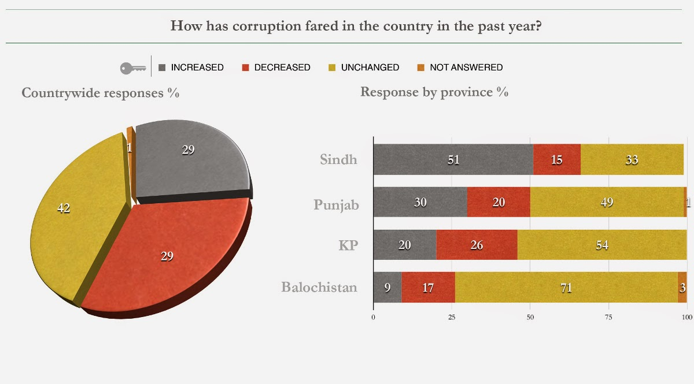

**Good Governance:**

Good governance is the process of measuring how public institutions conduct public affairs and manage public resources and guarantee the realization of human rights in a manner essentially free of abuse and corruption and with due regard for the rule of law.

**Causes of Bad Governance in Pakistan:**

* **Bribery:**
* Bribe serves as an incentive for the government servants.
* It is a kind of price that equates supply and demand in every field and office.
* "High inequality can lead to greater incentives for corruption".
* **Political objectives:**
* Despite having many corruption committees, and agencies, across the board, accountability cannot be implemented in the true sense.
* The main reason behind it is the political objectives that every government tries to achieve them either by disgruntling oppositions’ members or to suppress censorship.
* **Absence of accountability**:
* Political expediencies have made parliamentary committees on accountability redundant in their accountability drives.
* It is very rare that the meeting of the Public Accounts Committees is convened to discuss the complaints against officials, and to take exemplary actions against them.
* Such absence of accountability influences governance and make in worse rather than improving
* **Corruption:**
* Spiraling Scourge of Corruption is considered the mother of all social evils.
* It has permeated in every department of the government of Pakistan. Its wretched implications have affected the governance system of the state.
* It has become the priority of every official, businessman, even common individual to get advantages more and more in his respective field and become rich overnight.

***Impacts of corruption on Good Governance in Pakistan:***

Corruption has been the major hurdle in establishing good governance in Pakistan. It has destroyed the accountability system in Pakistan. It then resulted in bad governance in Pakistan.

* **Hindering National development:**
* The power struggle among the key state institutions i.e. the Legislature, the judiciary, and the parliament is also the one of the reasons that promoted bad governance in the country.
* They do not prefer to work in tandem with one another to enhance the efficiency and effectiveness of the government.
* **Conflict among the institutions:**
* Secondly, there exist numerous accountability agencies: **The Federal Investigation Agency**, The **National Accountability Bureau (NAB)**, the **Auditor General of Pakistan**, and provincial Anti-Corruption Agencies in each province to hold accountable the corrupt persons in the society.
* But, very often, these watchdogs’ come in conflict with one another over the matter of their jurisdictions that comes on the surface. In these cases, only corrupt factors take advantages.

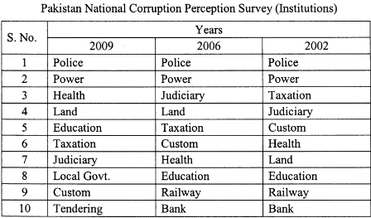

* **Destruction of legal system:**
* Corruption has undermined the rule of law by promoting a culture of impunity. When corrupt practices go unpunished, it destroys the foundations of a fair and just legal system.
* This has led to selective enforcement of laws and unequal protection under the law, further eroding public trust in the justice system.
* **Bad check and balance system:**
* Sometimes, executive tries to bypass the parliament. In the same vein, the Parliament also strives to assert its supremacy in the institutional hierarchy.
* Above all, the judiciary very often dominates all other institutions through its judicial activism or judicial constitutionalism. This leads to bad check and balance system.
* **Weak Institutions:**
* In Pakistan, corruption has eroded the effectiveness and credibility of public institutions. When officials engage in corrupt practices, the institutions responsible for ensuring good governance become weakened and compromised.
* This has led to a lack of trust in these institutions, hindering their ability to perform their functions efficiently.
* **Funds Misallocation:**
* Corrupt practices often result in the misallocation of funds. Public funds intended for development projects, social services, and infrastructure are siphoned off for personal gain.
* This misallocation has hinder economic growth of our country contributing to social and economic inequality.
* **Reduced Public Services:**
* Corruption diverts country’s resources away from essential services such as healthcare, education, and infrastructure, negatively impacting the well-being of the population.

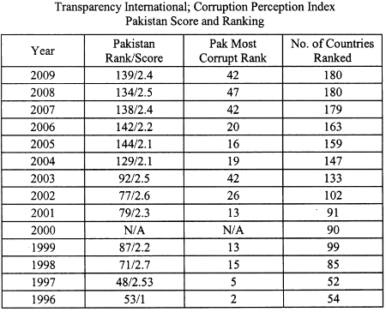

* **Social Injustice:**
* Corruption has exacerbated social inequalities in Pakistan as those with access to power and resources exploit their positions for personal gain.
* This has created an environment where social and economic opportunities are not distributed equitably, fostering resentment and social unrest.
* **Political Instability:**
* Widespread corruption has contributed to political instability in Pakistan. Almost every government is charged with money laundering cases etc.
* When citizens lose faith in the government's ability to govern transparently and address their needs, it can lead to protests, civil unrest, and political turmoil.
* **Economic failure:**
* Corruption can deter foreign investment, hinder economic growth, and create an unfavorable business environment.
* Investors may be hesitant to engage in a country with a reputation for corruption due to concerns about unfair competition, bribery, and a lack of legal protection.

***References:***

* ***Corruption and its deep impact on good governance in Pakistan***

***(Umbreen Javaid) published in Pakistan economic and social review (Summer 2010)***